Mobis Doc – Information Technology

*“HOW TO INSTALL AND CONFIGURE SUBVERSION WITH* ***VisualSVN******Server*** *&* ***TortoiseSVN*** *TOOLS”*

# Download the Installer for VisualSVN Server from:

<https://www.visualsvn.com/server/?gclid=Cj0KCQjwiLDMBRDFARIsACNmiX8lPTCzR1N8aPBfaNQiYQwm_TmGgr8dC3YClMAq1Geg9WVu967oROIaAuVDEALw_wcB>

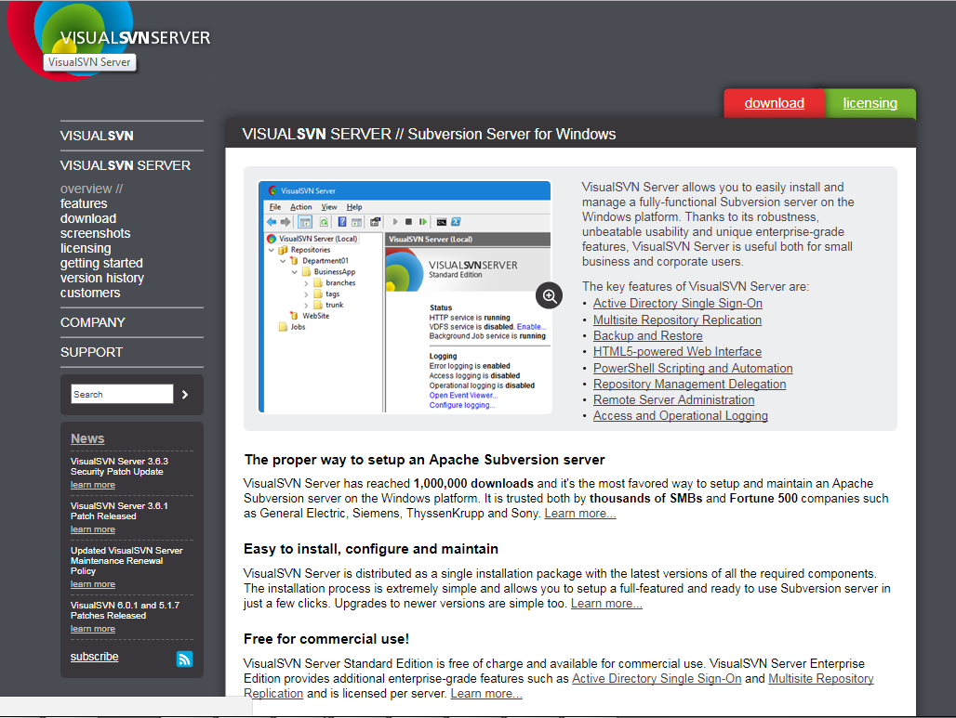

# VisualSVN Server – Installation Process

## Welcome

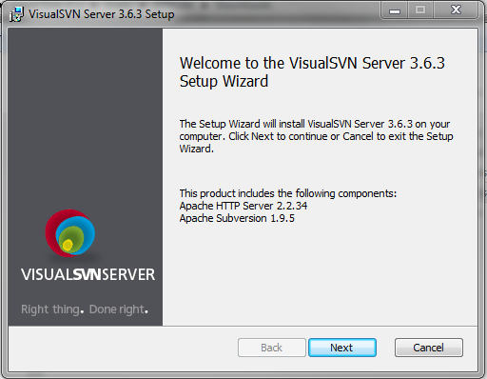

## End-User License Agreement

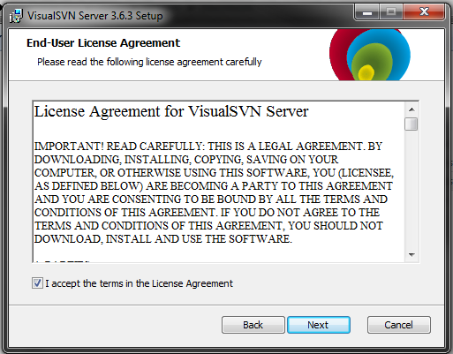

## Select Components

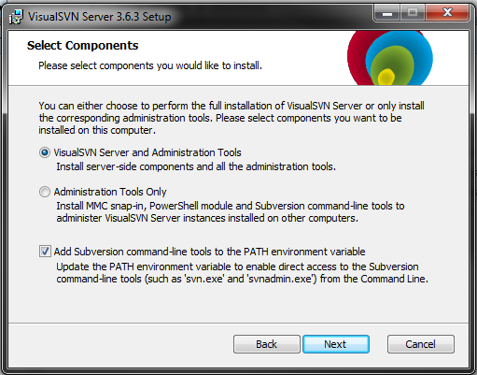

## Select Version

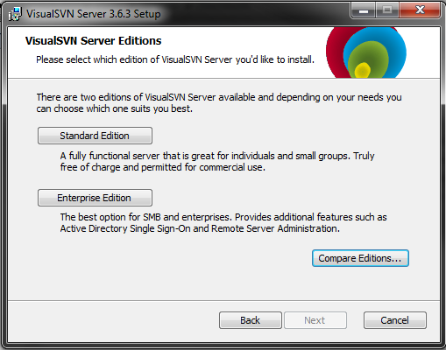

There are presently two versions of SVN, Enterprise and Standard. Enterprise offers some exclusive benefits such as remote administration but licensing costs almost $1,000 per license (server). This demo will illustrate the Standard Edition.

## Directory Settings

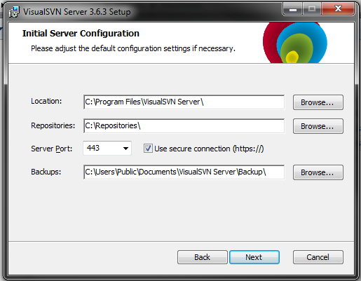

The default settings are fine for your repository directory but ensure that (https://) a secure connection is used by your server!!

## That’s it! – You are ready to install VisualSVN

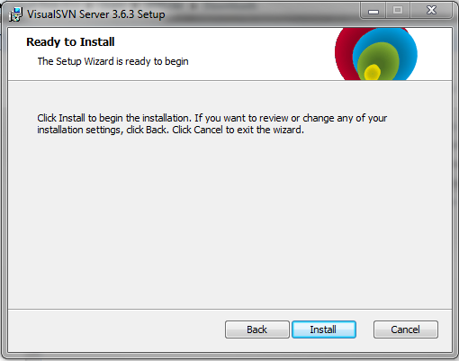

# Download the Installer for TortoiseSVN from:

<https://tortoisesvn.net/downloads.html>

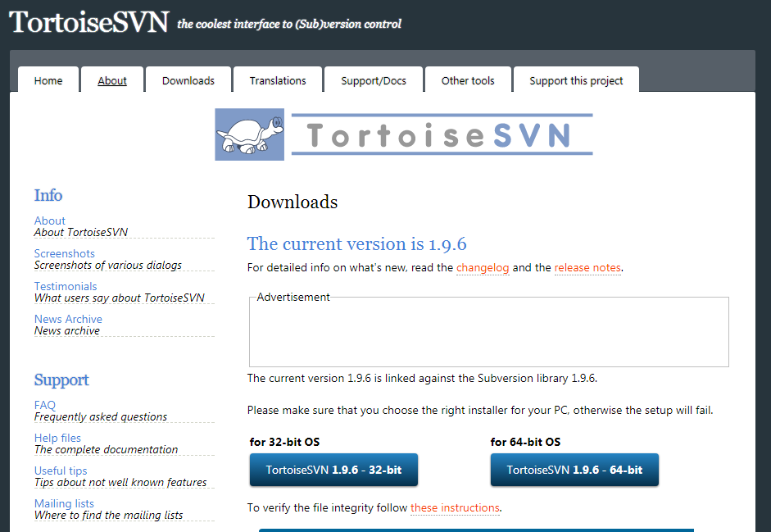

*** The 32-bit can be used for 32-bit versions of the Windows Operating system or 64-bit bit versions. The 64-bit version of TortoiseSVN should only be utilized on 64-bit versions of the Windows Operating System.

# TortoiseSVN – Installation Process

## Welcome



## End-User License Agreement

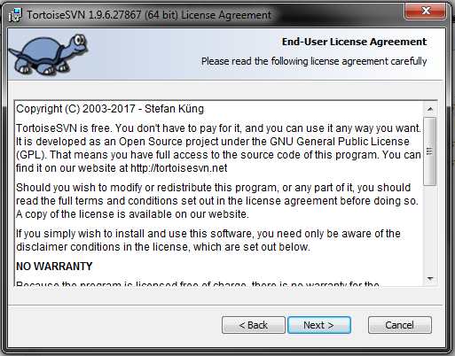

## Select Components

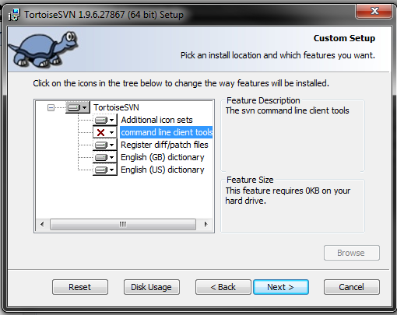

***Select to install command line client tools can be beneficial  
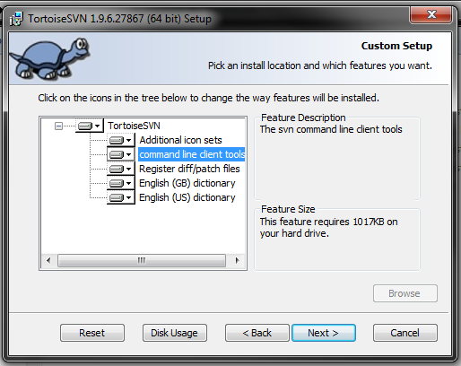

## That’s it! – You are ready to install TortoiseSVN

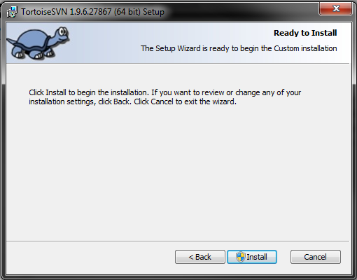

***Admin privilege will be required by the windows installer

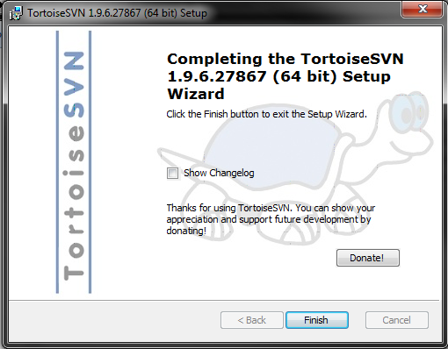

# VisualSVN Server – Setting up a user

## Open VisualSVN Server Manager

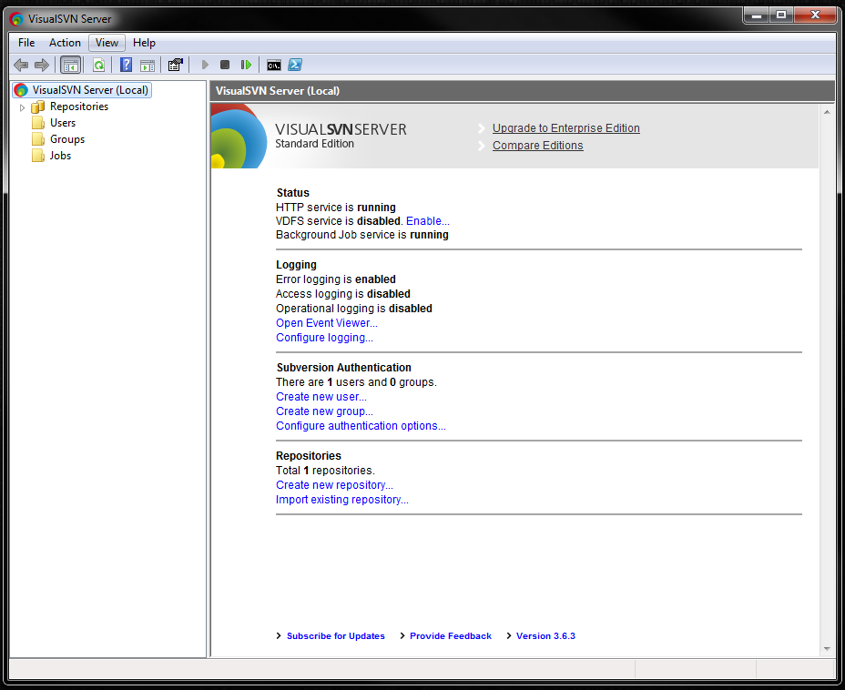

## Right-click user -> Create User

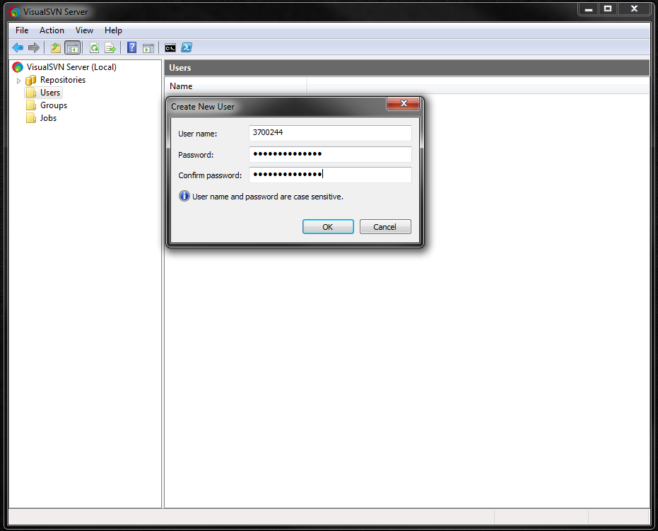

*You can now name a user and assign a password for authentication.

**The Mobis standard is used here as an example.

***Groups or teams are discouraged from creating shared user accounts as this defeats the purpose of version control and ownership for modifying files.

# VisualSVN Server – Setting up a repository

## Create a new repository

### Right-click Repositories -> Create New Repository

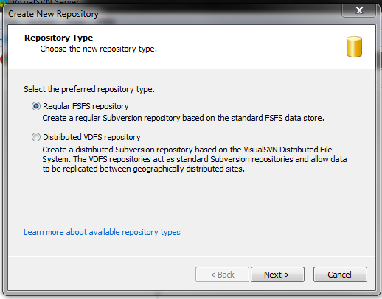

*Choose the type of repository:

**Regular Repository will be for repositories located on the same server as the original data.

**Distributed Repository will be used for repositories hosting data from another server location.

### Choose a name for the new repository

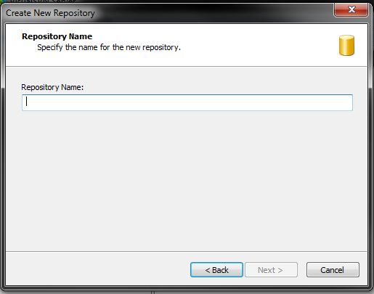

### Choose the repository structure

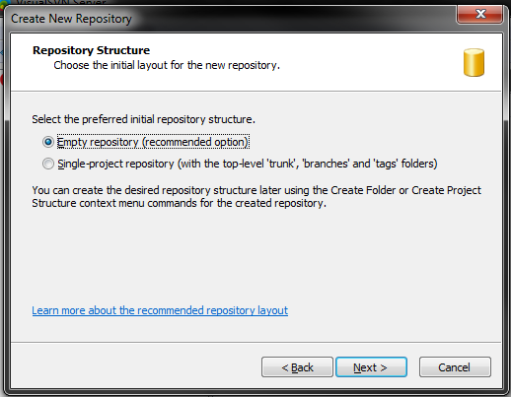

*An empty repo will be used for multiple projects or files of multiple projects. This is the recommended default.

**A “Single-project repository” is a good choice for a single user to create a repo for their personal version-control using subversion.

### Set “Access Permissions” for the new Repository

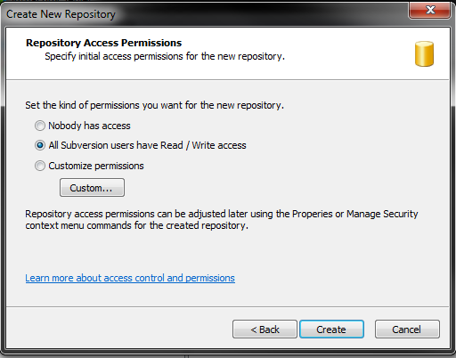

*Nobody has access – Useless

**All Subversion users have Read/Write access

***Customize permissions – Select which users have Read and/or Write access

# TortoiseSVN – Context Menu Use Cases

The default context menu will include options to:

## Checkout…

Use this option to save a local version of the file or folder and begin branching changes to later merge with other users.

## Update…

Use this option to pull the changes from the master copy to your local copy.

## Commit…

Use this option to commit changes from your local copy to the master copy to later be merged with other user changes.